RAILWAY RESERVATION SYSTEM
Low Level Design (LLD)
C# / .NET Microservices Backend

Document Item | Value
Project | Railway Reservation System
Document Type | 1.1
Version | 1.4
Technology | C# / .NET / ASP.NET Core / EF Core / SQL Server
Architecture | Microservices + layered application architecture
Status | Updated design baseline
Date | 07 September 2026

Document Control
Version | Date | Author | Description
1.4 | 07-Sep-2026 | Project Team | Added waitlist journey-start rule, explicit full fare for adults/children, Login/JWT and cancellation API examples, and terminology cleanup.

Table of Contents
1. Document Purpose
2. Intended Audience
3. Project Background & Objectives
4. Architectural Design / Design Pattern
5. Solution Diagram
6. Use Case Diagram
7. Domain Model
8. Detailed Class Design
9. Solution Steps / Business Flows

9.1 Public Train Information
- Client requests public train information.
- Gateway routes train search/details/schedule/fare requests to Train Service and availability requests to Reservation Service; authentication is not required.
- Train Service reads train, route and fare data as applicable; Reservation Service calculates current seat availability using Reservation DB allocations and Train Service route/coach data.
- Client displays the returned information to the passenger.
10. Flow & Sequence Diagrams
11. Validations & Business Rules
12. Database Architecture
13. ER Diagram
14. Detailed Data Model / Tables
15. API Canvas
16. API Request / Response
17. Environment Variables & Configuration
18. Integrations / Inter-Service Communication
19. Infrastructure / Deployment
20. HTTP Status Codes & Error Handling
21. Unit Testing (NUnit)
22. Design Notes / Assumptions
Appendix A — C# Implementation Reference

1. Document Purpose
This document defines the low-level design for the Online Railway Reservation System. It translates the functional HLD into an implementation-oriented design covering service boundaries, application layers, domain entities, database ownership, APIs, business flows, validation, error handling, configuration, integrations and testing.

2. Intended Audience
Audience | Purpose
Developers | Implementation reference for C#/.NET services, APIs, EF Core and business logic.
Architects | Review service boundaries, data ownership, integrations and design decisions.
Business Analysts / SMEs | Validate that business requirements are represented.
QA / Test Engineers | Derive unit, integration, API and negative test cases.
Reviewers | Understand the overall technical solution and implementation approach.

3. Project Background & Objectives

3.1 Background
The supplied HLD describes an online railway reservation system supporting advance booking between stations. It provides train details, timetable, fares, reservation position and accommodation availability, with public train information available without login. Registered passengers can reserve, view and cancel tickets, while administrators maintain railway master data and fares.

3.2 Objectives
- User registration, login and role-based access using a JWT issued by User Service; roles are maintained in the User DB Roles table.
- Public train search, train details, schedule, fare and seat/accommodation availability without login.
- Booking for 1–6 passengers with atomic all-confirmed or all-waitlisted behavior.
- General and Ladies quota support.
- Full payment before a booking becomes Confirmed or Waitlisted; waitlisted bookings are paid immediately.
- Adult and child passengers are charged the applicable full fare; no child fare discount is applied in the current scope.
- PNR generation for successful confirmed or waitlisted booking requests.
- Cancellation before journey start with full refund and seat release.
- Strict FIFO waitlist promotion only when enough seats exist for the entire waiting booking; promoted bookings do not pay again.
- Administration of trains, stations, routes/schedules, coaches/seats and fares.
- Independent database ownership for User, Train, Reservation and Payment services; Mail Service has no database in the current scope.

3.3 Key Business Rules
- No partial booking: either all requested passengers are confirmed or the booking is waitlisted.
- No RAC in the current design.
- Waitlisted bookings are paid immediately.
- Payment failure produces no final booking/waitlist entry.
- A waitlisted booking is promoted only if enough seats exist for the entire booking.
- Waitlist is strict FIFO; later entries are not skipped.
- Only the booking owner may cancel and only before journey start.
- Cancellation releases seats and triggers promotion.
- Promoted bookings do not require a second payment.
- Train Service owns current fares; Booking.TotalFare preserves the amount charged. Reservation stores no raw card/CVV data; payment processing is handled by Payment Service and its Dummy Razorpay Gateway.
Booking notifications are sent to the registered email address of the authenticated booking owner. Email is collected during user registration and is not requested again during booking.
Mail Service has no database in the current scope; notification failure does not roll back the underlying booking, cancellation or promotion operation.
Payment Service uses the Dummy Razorpay Gateway as an external payment dependency; Mail Service uses the external SMTP Server. HTTP-facing applications register Global Exception Middleware for consistent error responses.

4. Architectural Design / Design Pattern

4.1 Architecture
Client
↓
API Gateway
↓
Microservice Controller
↓
Application Service
↓
Repository Interface
↓
Repository / EF Core
↓
Service-owned Database

4.2 Services
Service | Responsibility | Database
API Gateway | Client entry point, routing and JWT/role authorization. | None
User Service | Registration, authentication, users and roles. | User DB
Train Service | Trains, stations, routes/schedules, coaches, seats and fares. | Train DB
Reservation Service | Bookings, passengers, availability, allocations, waitlist, cancellation and orchestration. | Reservation DB
Payment Service | Payment/refund processing and payment persistence. | Payment DB
Mail Service | Build/send booking, cancellation and promotion notifications through SMTP. | None

4.3 Architectural Principles
- Each data-owning microservice owns its database; Mail Service is stateless in the current scope.
- No cross-database foreign keys; cross-service IDs are logical references.
- No direct database access between services.
- REST/HTTP + JSON for service-to-service communication.
- DTOs isolate service contracts from persistence entities.
- Reservation Service orchestrates booking, cancellation, payment/refund, seat release, waitlist promotion and notifications.
- Complex infrastructure such as Kafka, Redis, Kubernetes, complex load balancing and event-bus infrastructure is outside the current scope.

5. Solution Diagram
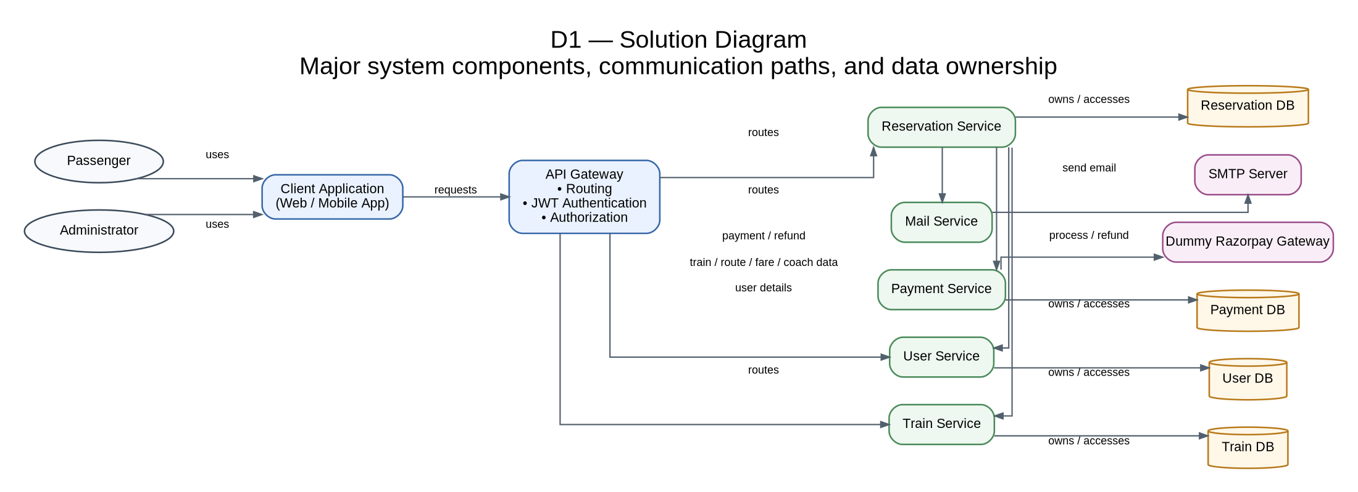
Figure 1. Solution Diagram (D1).
The Gateway routes client requests only to User, Train and Reservation services. Reservation Service coordinates User, Train, Payment and Mail interactions. Payment Service communicates with the Dummy Razorpay Gateway, while Mail Service communicates with the external SMTP Server. User, Train, Reservation and Payment services own their respective databases; Mail Service has no database in the current scope.

6. Use Case Diagram
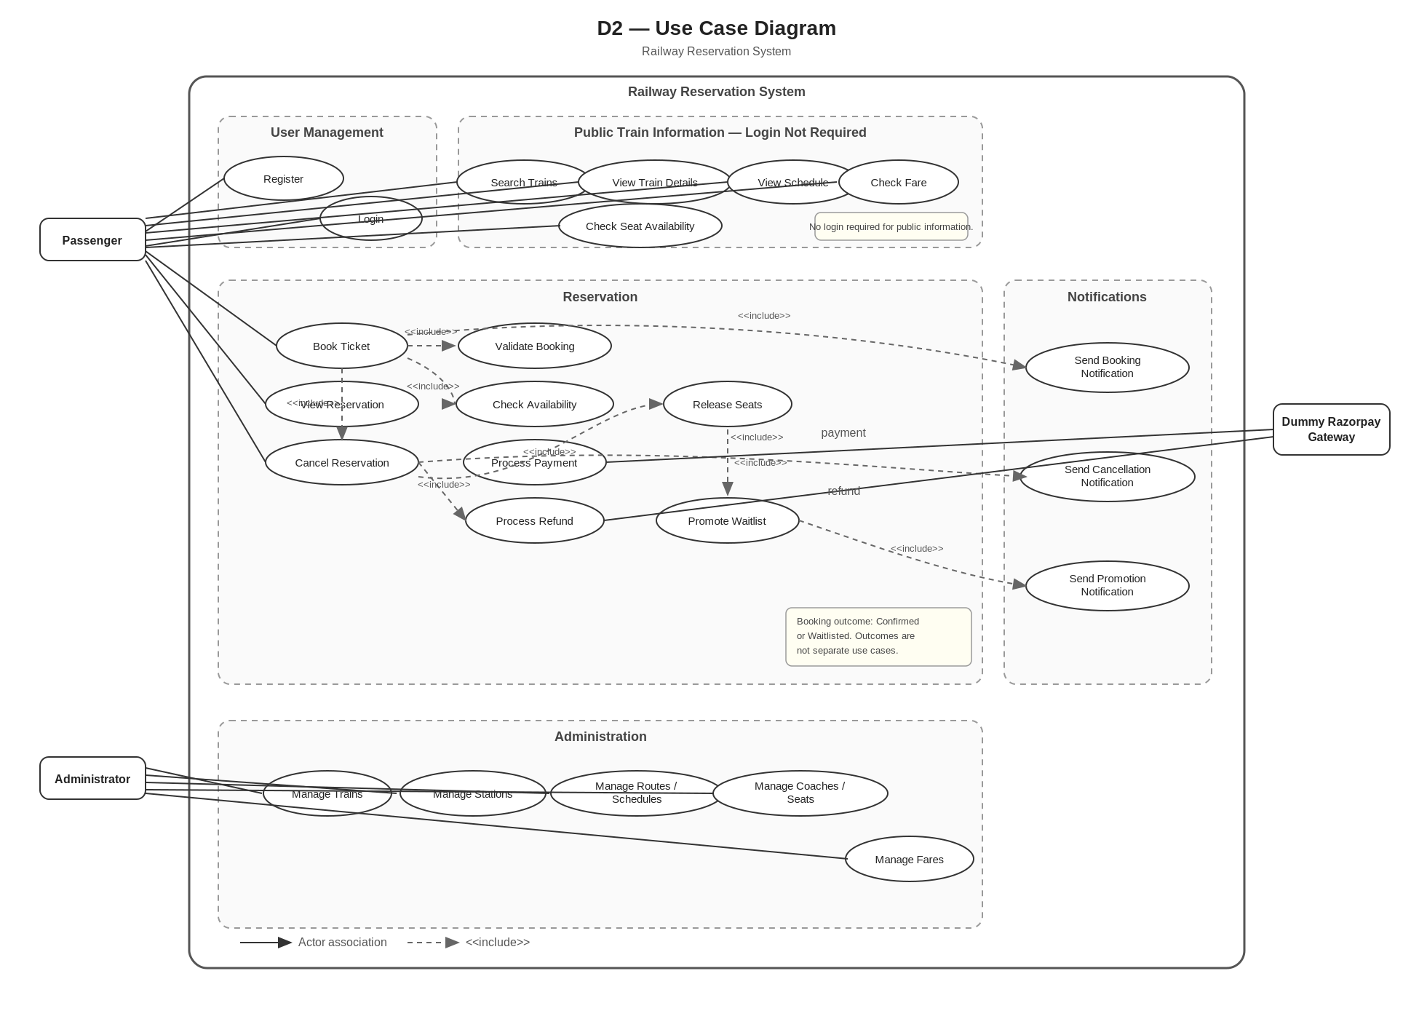
Figure 2. Use Case Diagram (D2).
The use-case model distinguishes public train-information operations from authenticated reservation operations. Passenger functions include registration, login, public train search/details/schedule/fare/availability, booking, reservation viewing and cancellation. Booking, cancellation and promotion include the important validation, payment/refund, seat-release, waitlist and notification behaviors. Administrator functions cover railway master data. The Dummy Razorpay Gateway participates in payment and refund processing; SMTP is an implementation dependency of Mail Service rather than a use-case actor.

7. Domain Model

7.1 User Service
User contains account identity/contact data and a RoleId reference to the Role entity. Role is a persisted User DB entity with a unique Name; the initial roles are Passenger and Administrator. UserService uses IUserRepository and IRoleRepository. Normal registration assigns Passenger and does not accept a client-supplied RoleId. Login retrieves the user role and places the role name in the JWT claims used for authorization.
Entity | Purpose
User | Account identity, contact data, password hash, RoleId and creation time.
Role | Persisted role definition; initial roles are Passenger and Administrator.

7.2 Train Service
Entity | Purpose
Train | Train master data.
Station | Station code and name.
RouteStop | Ordered stop with arrival/departure time.
Coach | Coach number and class.
Seat | Physical seat belonging to a coach.
Fare | Fare for train, station pair and coach type.

Route is represented by ordered RouteStop records. Seat availability is dynamic and is not stored as an IsAvailable flag.

7.3 Reservation Service
Entity | Purpose
Booking | PNR, user/train references, journey, class, quota, status and total fare.
BookingPassenger | Passenger details; one booking contains 1–6 passengers.
SeatAllocation | Passenger-to-seat mapping plus journey segment.
WaitlistEntry | FIFO position for a waitlisted booking.

7.4 Payment Service
Payment Service owns Payment persistence and exposes ProcessPayment and Refund through IPaymentService. It uses IPaymentGateway, implemented by DummyRazorpayGateway in the current project. The dummy gateway represents an external Razorpay-like dependency; it does not own a business database and no raw card/CVV/bank credentials are stored.
Entity | Purpose
Payment | Amount, status, transaction reference and BookingId logical reference.
PaymentStatus | Pending, Successful, Failed or Refunded.

7.5 Mail Service
Mail Service receives internal notification requests, selects/builds the required template, and sends mail through SmtpMailSender to the external SMTP Server. It does not persist email history in the current scope. Supported notification templates are BookingConfirmed, BookingWaitlisted, Cancellation and WaitlistPromotion.

8. Detailed Class Design

8.1 Project Structure
RailwayReservationSystem
├── ApiGateway
├── UserService
├── TrainService
├── ReservationService
├── PaymentService
├── MailService
├── DummyRazorpayGateway
├── UserService.Tests
├── TrainService.Tests
├── ReservationService.Tests
├── PaymentService.Tests
├── MailService.Tests
└── ApiGateway.Tests

8.2 Internal Service Structure
Common ASP.NET Core application structure:
├── Controllers
├── Services
├── Repositories (where persistence is required)
├── Entities (where persistence/domain entities are required)
├── DTOs
├── Enums
├── Data (where persistence is required)
├── Exceptions
├── Middleware
└── Program.cs
GlobalExceptionMiddleware is registered in each HTTP-facing application to provide consistent exception-to-HTTP handling. Mail Service additionally contains SmtpMailSender and has no repository/DbContext in the current scope.

8.3 UML Class Diagram
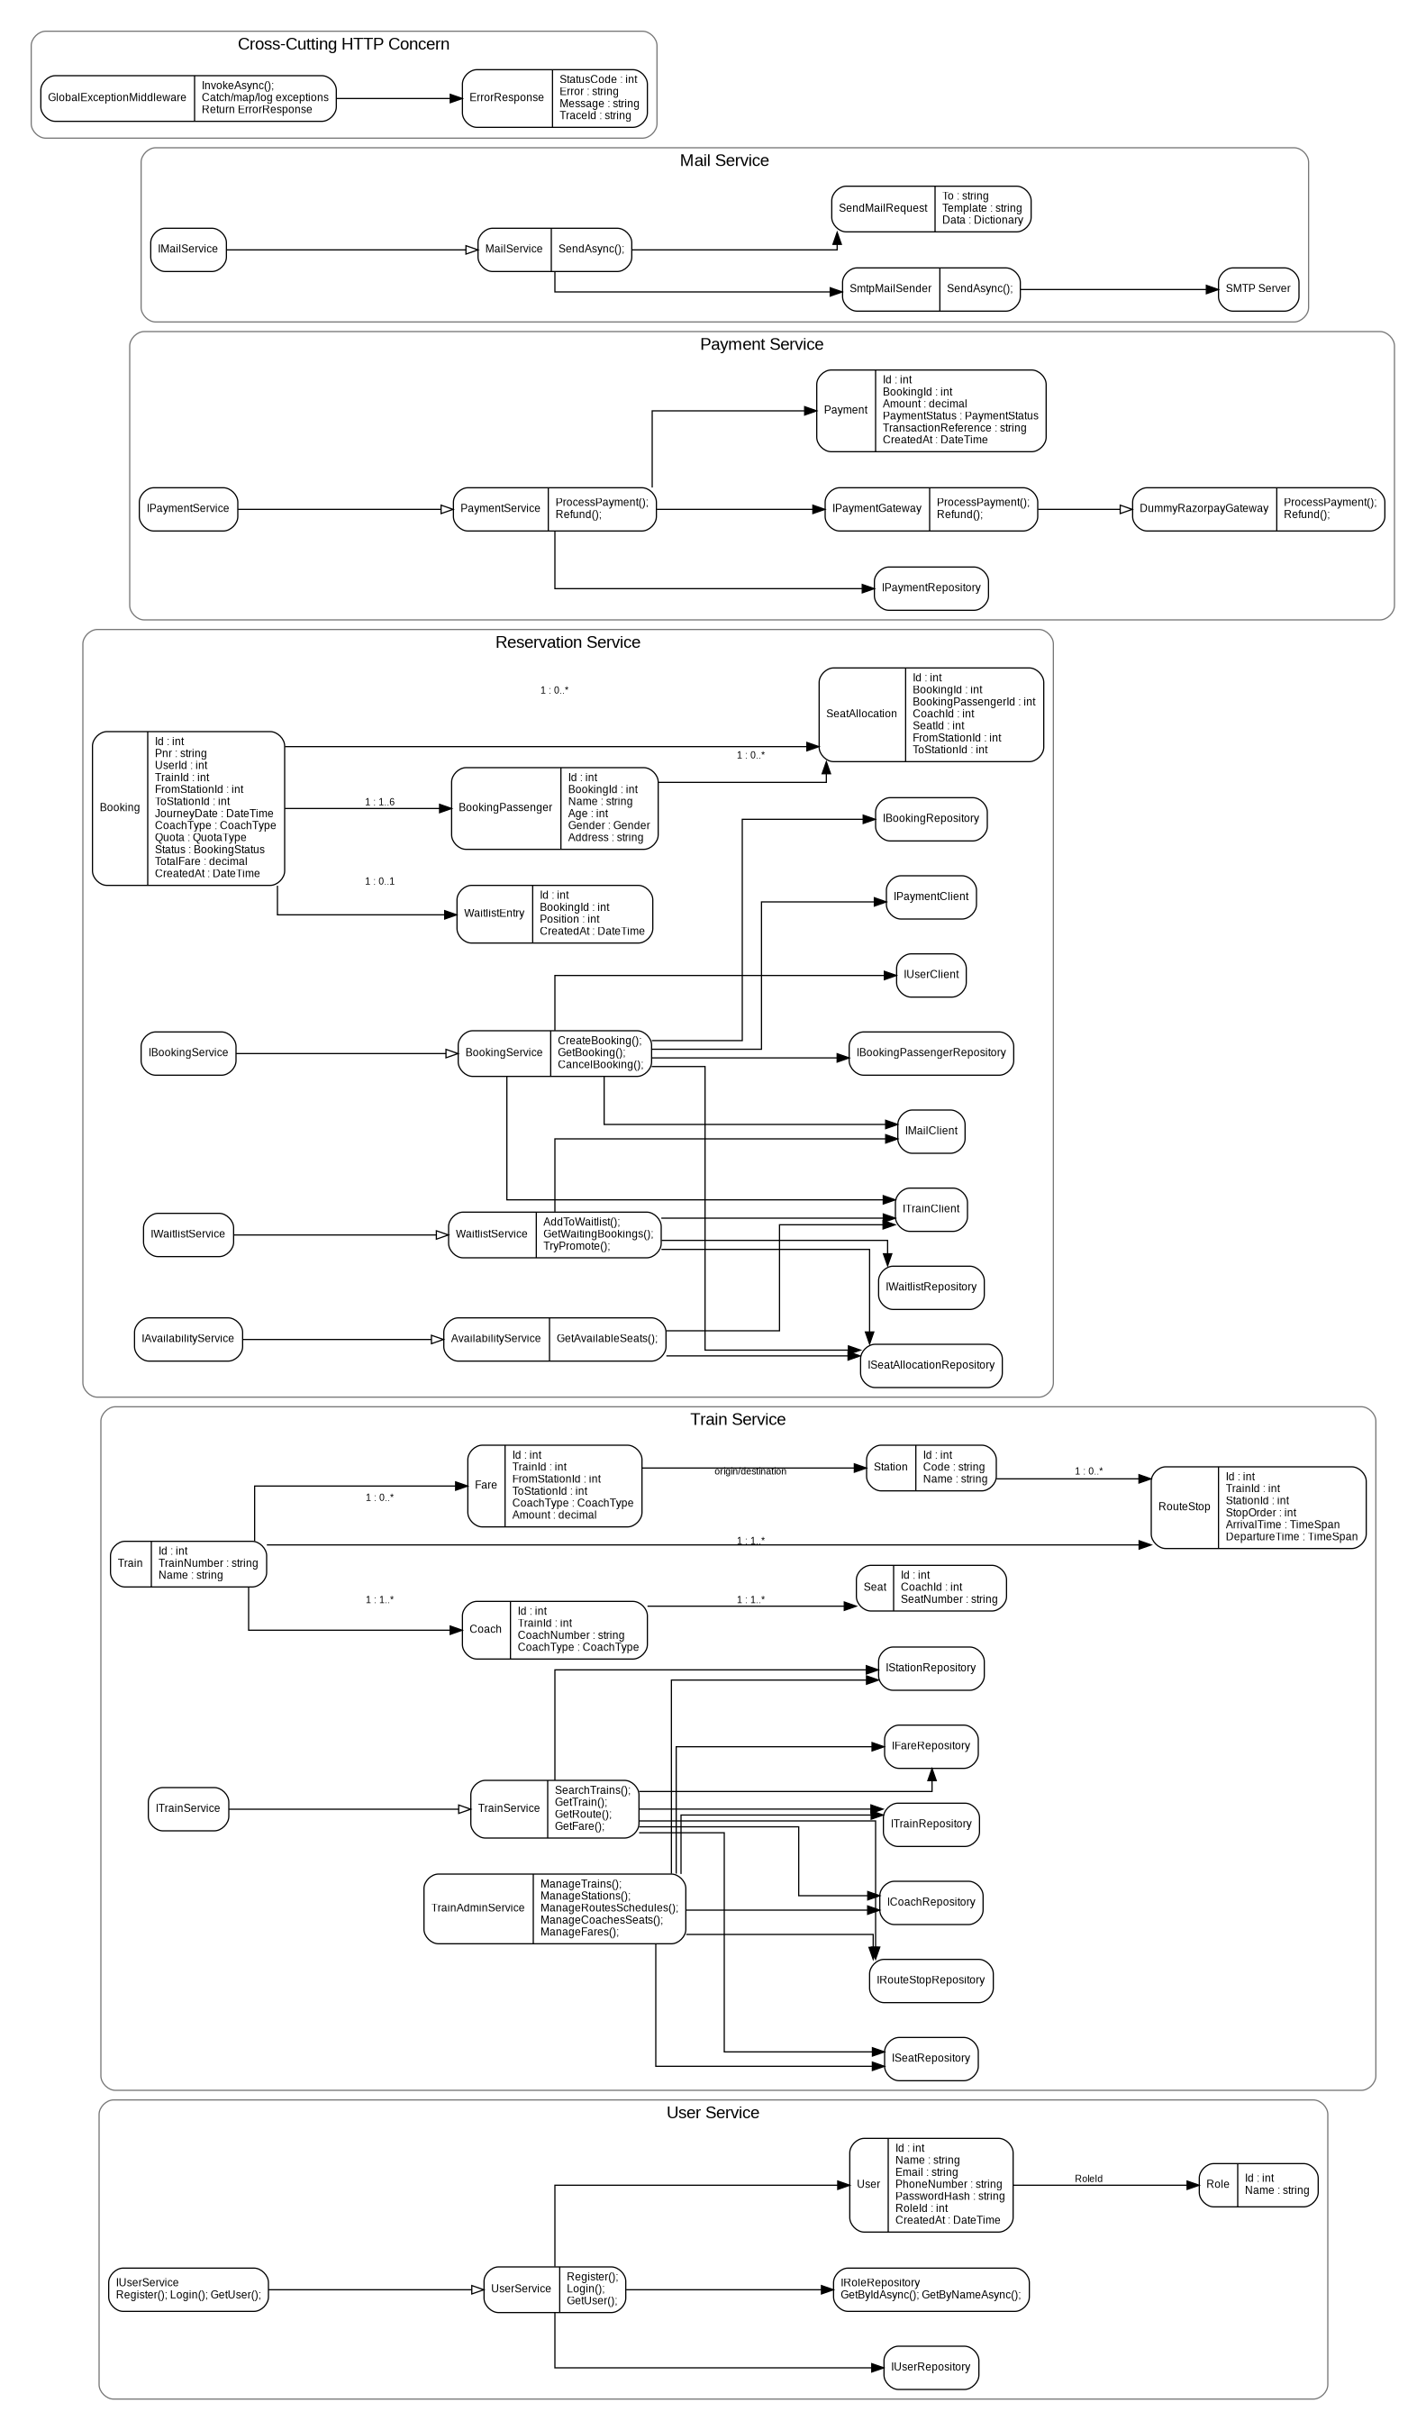
Figure 3. UML Class Diagram (D3).

8.4 Key Interfaces
Interface | Representative Methods / Responsibility
IUserService | Register, Login, GetUser
ITrainService | SearchTrains, GetTrain, GetRoute, GetFare
IBookingService | CreateBooking, GetBooking, CancelBooking
IAvailabilityService | GetAvailableSeats
IWaitlistService | AddToWaitlist, GetWaitingBookings, TryPromote
IPaymentService | ProcessPayment, Refund
IUserClient | Call User Service
ITrainClient | Call Train Service
IPaymentClient | Call Payment Service
IMailService | SendAsync
IMailClient | Call Mail Service
IPaymentGateway | ProcessPayment, Refund
IRoleRepository | GetByIdAsync, GetByNameAsync; role lookup for registration/authentication.

8.5 Important Relationships
- Booking has 1–6 BookingPassenger records.
- SeatAllocation references both Booking and BookingPassenger.
- Booking has zero or one WaitlistEntry.
- Train has many RouteStops and Coaches; Coach has many Seats.
- Fare is uniquely identified by Train + FromStation + ToStation + CoachType.
- Cross-service IDs are ordinary identifier properties, not EF Core foreign keys.
Mail Service uses SmtpMailSender to communicate with SMTP and does not own a database. Payment Service uses IPaymentGateway with DummyRazorpayGateway as the current implementation. Global Exception Middleware is a cross-cutting HTTP concern that converts application/unhandled exceptions into the standard ErrorResponse format.

9. Solution Steps / Business Flows

9.2 Registration
- Client submits registration data.
- Gateway routes to User Service.
- Validate required fields and email/phone uniqueness.
- Hash password, assign the default Passenger role from the Roles table, and create the user.
- Return success response.

9.3 Login
- Client submits registered email or phone and password.
- User Service authenticates the user.
- Generate a signed JWT on success, including the authenticated user identity and role claim.
- Client sends the JWT as a Bearer token for authenticated operations; the API Gateway validates the token and enforces role-based authorization.

9.4 Train Search
- Client submits source, destination and journey criteria.
- Train Service validates route criteria and searches ordered RouteStops.
- Return matching trains and schedule information.
- Fare is obtained from Train Service and current seat availability is obtained from Reservation Service when requested.

9.5 Confirmed Booking
- Validate user, passenger count, journey, route, class and quota.
- Get train/route information and current fare.
- Check segment-based availability for all passengers.
- Process full payment.
- Create booking, passenger rows and seat allocations.
- Generate PNR and return confirmation.

9.6 Waitlisted Booking
- If sufficient seats are unavailable for all passengers, do not partially confirm.
- Process full payment.
- Create Waitlisted booking and FIFO WaitlistEntry.
- Generate PNR and return position.

9.7 Cancellation & Promotion
- Validate PNR, ownership, status and journey date.
- Mark booking Cancelled and release allocations.
- Process full refund.
- Check the first FIFO waitlisted booking only; do not skip later entries.
- Promote only if enough seats exist for the entire waiting booking; allocate seats, confirm the booking, remove the waitlist entry and notify the owner without charging again.

10. Flow & Sequence Diagrams

10.1 Flow Diagram (D5)
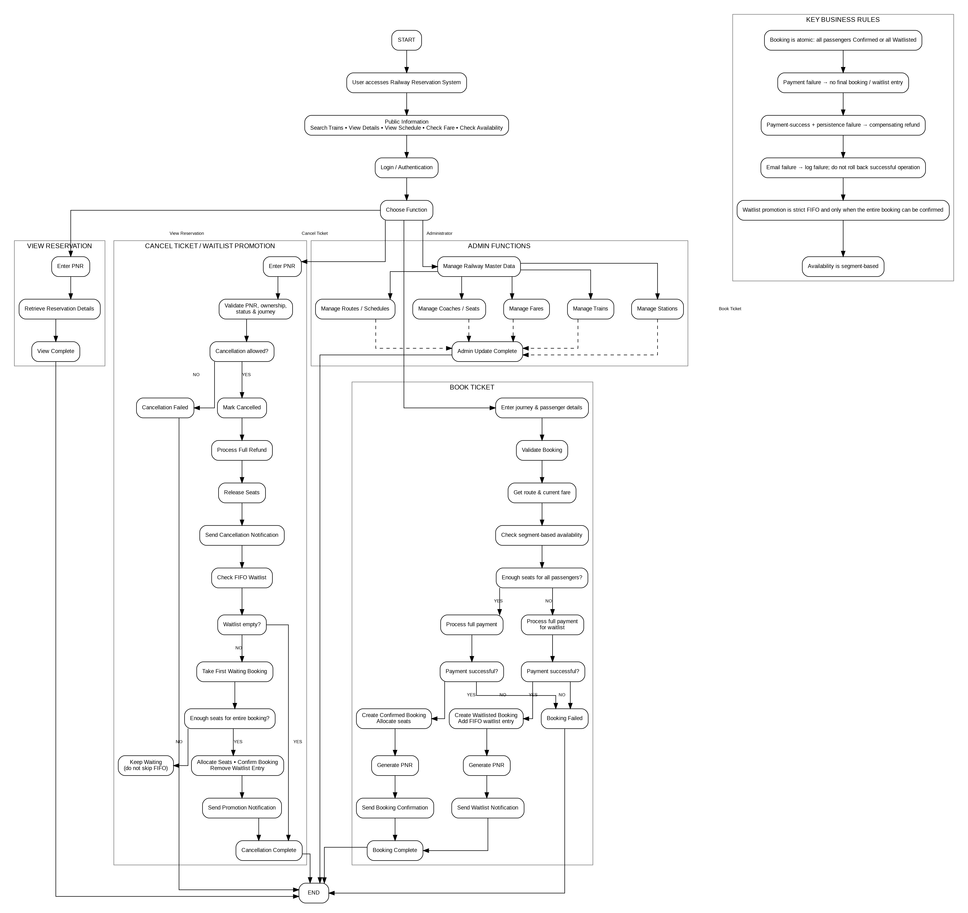
Figure 5. Overall Project Flow (D5): public information, user management, booking, reservation viewing, cancellation/waitlist and administration.

10.2 Sequence Diagram (D7)
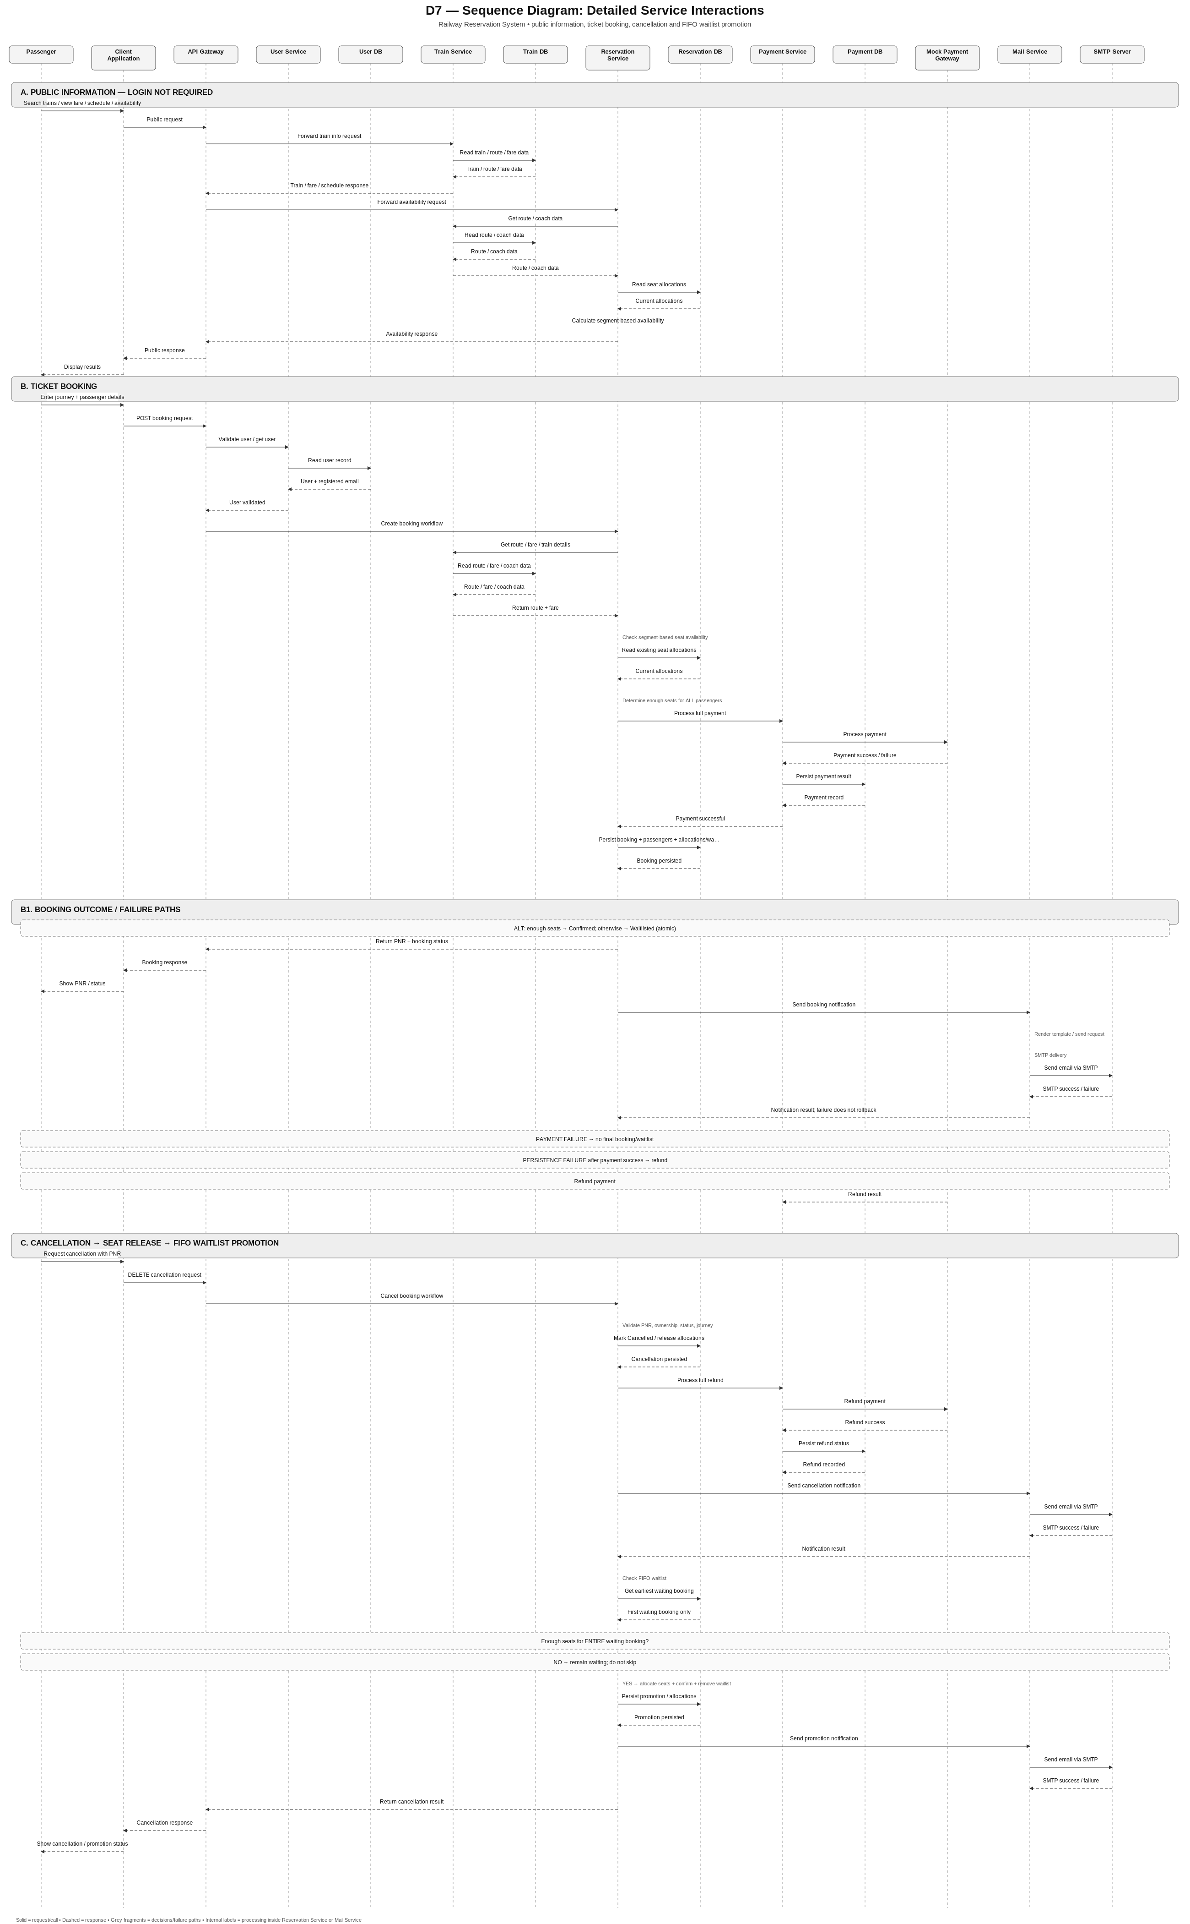
Figure 7. Sequence Diagram (D7): public information, JWT-authenticated booking, cancellation and FIFO waitlist promotion. Payment uses the Dummy Razorpay Gateway and notifications use SMTP.
Note: Booking, Availability and Waitlist processing are internal components/services of Reservation Service, not separate microservices. D7 uses three interaction regions: public information, ticket booking, and cancellation with FIFO waitlist promotion.

11. Validations & Business Rules
Fare for Adults and Children: Adult and child passengers are charged the applicable full fare; no child fare discount is applied in the current scope.
Waitlist expiry: Waitlisted bookings are eligible for promotion only until the journey starts. After journey start, no further waitlist promotion is performed. Automatic expiry or cancellation of waitlisted bookings is outside the current scope.

11.1 Validation Matrix
Area | Validation
Passenger count | 1–6 passengers.
Source / Destination | Both valid route stops; source precedes destination.
Journey date | Valid bookable journey date.
Coach type | Supported coach class.
Quota | General or Ladies.
Passenger data | Name, age, gender and address required.
Cancellation | Owner only; booking must not already be cancelled; journey not started.
Payment | Full fare required before final booking/waitlist state; payment success followed by persistence failure requires a compensating refund.

11.2 Segment Overlap
A physical seat may be reused for non-overlapping journey segments. The conflict rule is:
existingFromOrder < requestedToOrder
&& requestedFromOrder < existingToOrder
Example: A→C conflicts with B→D, but A→C can be followed by C→E.

11.3 Concurrency
Availability checking and seat allocation must be protected by a Reservation DB transaction and appropriate isolation/locking. The current design does not require Redis or a distributed lock.

12. Database Architecture
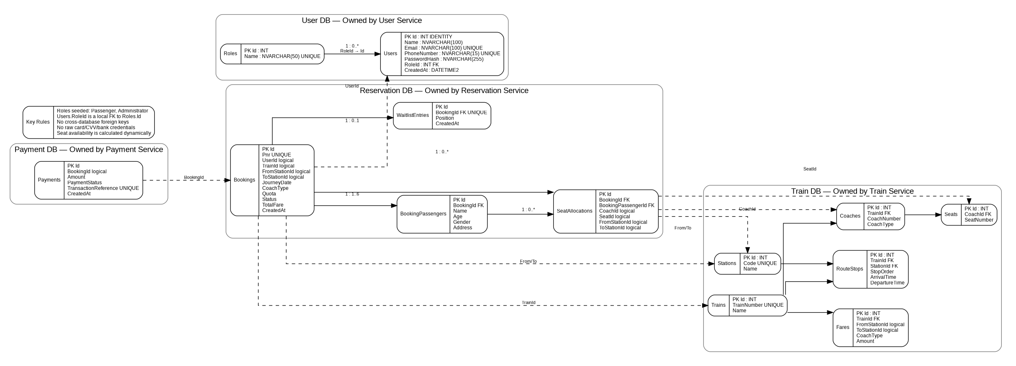
Figure 4. Database Architecture (D4).
User, Train, Reservation and Payment services each own a separate database. Mail Service, API Gateway, Dummy Razorpay Gateway and SMTP Server do not have application databases in the current scope.

13. ER Diagram
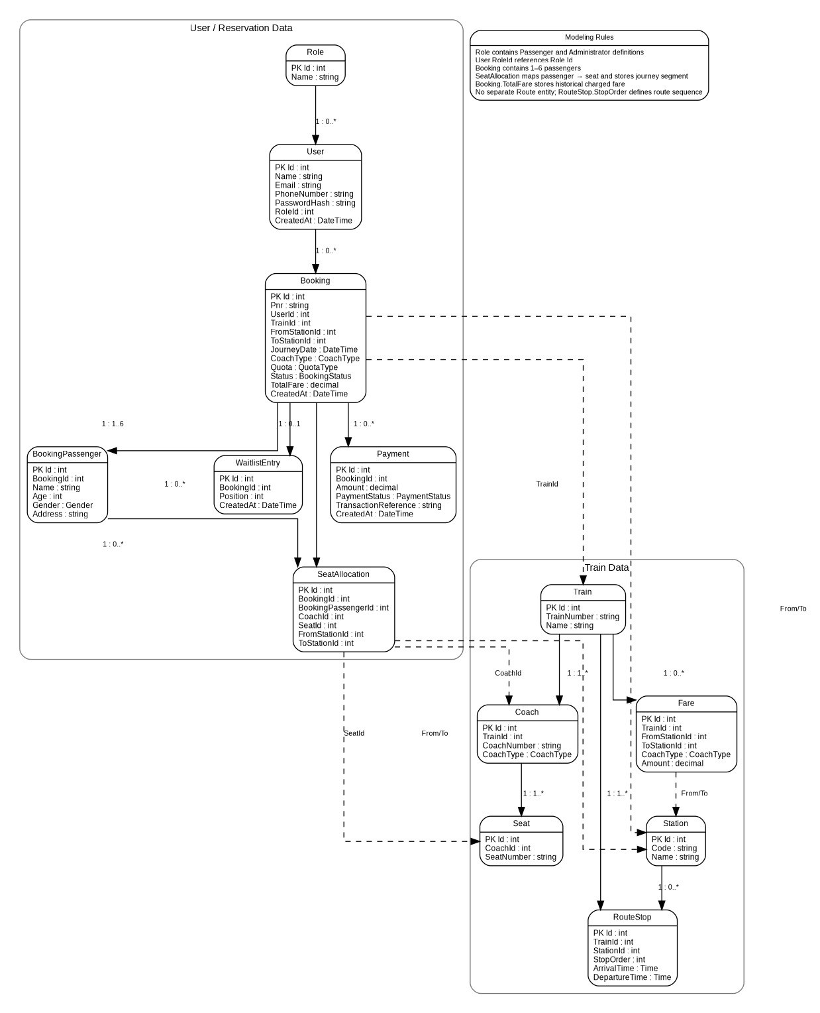
Figure 6. ER Diagram (D6).
The ER view reflects the finalized service-owned database model. The User DB contains Users and Roles, with Users.RoleId as a local foreign key to Roles.Id. Cross-service identifiers are logical references; only relationships within a service database are enforced with database foreign keys. Section 14 is authoritative for table definitions.

14. Detailed Data Model / Tables

14.1 User DB
User DB contains Users and Roles. Users.RoleId is a local foreign key to Roles.Id and Role.Name is unique. Initial roles are seeded as Passenger and Administrator. Normal registration assigns Passenger and does not accept a client-supplied RoleId.
Table | Column | Type | Constraints
Users | Id | INT | PK, Identity
Users | Name | NVARCHAR(100) | NOT NULL
Users | Email | NVARCHAR(100) | NOT NULL, UNIQUE
Users | PhoneNumber | NVARCHAR(15) | NOT NULL, UNIQUE
Users | PasswordHash | NVARCHAR(255) | NOT NULL
Users | RoleId | INT | NOT NULL, FK → Roles.Id
Users | CreatedAt | DATETIME2 | NOT NULL
Roles | Id | INT | PK, Identity
Roles | Name | NVARCHAR(50) | NOT NULL, UNIQUE

14.2 Train DB
Table | Key Fields / Constraints
Trains | Id PK; TrainNumber UNIQUE; Name
Stations | Id PK; Code UNIQUE; Name
RouteStops | Id PK; TrainId FK; StationId FK; StopOrder UNIQUE per Train; ArrivalTime; DepartureTime
Coaches | Id PK; TrainId FK; CoachNumber UNIQUE per Train; CoachType
Seats | Id PK; CoachId FK; SeatNumber UNIQUE per Coach
Fares | Id PK; TrainId/FromStationId/ToStationId; CoachType; Amount; unique composite key

14.3 Reservation DB
Table | Key Fields / Constraints
Bookings | Id PK; Pnr UNIQUE; UserId/TrainId/stations logical refs; JourneyDate; CoachType; Quota; Status; TotalFare; CreatedAt
BookingPassengers | Id PK; BookingId FK; Name; Age; Gender; Address
SeatAllocations | Id PK; BookingId FK; BookingPassengerId FK; CoachId/SeatId/stations logical refs; segment-based allocation
WaitlistEntries | Id PK; BookingId FK UNIQUE; Position; CreatedAt

14.4 Payment DB
Table | Key Fields / Constraints
Payments | Id PK; BookingId logical ref; Amount; PaymentStatus; TransactionReference UNIQUE; CreatedAt; no raw card/CVV/bank credentials

14.5 Important Indexes
- Users.Email and Users.PhoneNumber — unique.
- Trains.TrainNumber and Stations.Code — unique.
- RouteStops(TrainId, StopOrder) and RouteStops(TrainId, StationId) — unique.
- Coaches(TrainId, CoachNumber) and Seats(CoachId, SeatNumber) — unique.
- Fares(TrainId, FromStationId, ToStationId, CoachType) — unique.
- Bookings.Pnr — unique; Bookings(TrainId, JourneyDate) — lookup index.
- SeatAllocations(BookingId), SeatAllocations(BookingPassengerId), SeatAllocations(SeatId) — lookup indexes.
- WaitlistEntries.BookingId — unique.
WaitlistEntries(Position) — supports FIFO evaluation; SeatAllocations(SeatId, FromStationId, ToStationId) — supports segment-overlap checks.

15. API Canvas
Service | Method | Endpoint | Auth | Description
User | POST | /api/users/register | No | Register passenger
User | POST | /api/users/login | No | Login with registered email/phone and issue JWT
User | GET | /api/users/{id} | Internal/Auth | Get user / registered email
Train | GET | /api/trains/search | No | Search trains between stations
Train | GET | /api/trains/{id} | No | Train details
Train | GET | /api/trains/{id}/route | No | Route / schedule
Train | GET | /api/fares | No | Fare lookup
Reservation | GET | /api/availability | No | Check seat/accommodation availability for train/date/station segment/class
Train | POST | /api/admin/trains | Admin | Create train
Train | PUT | /api/admin/trains/{id} | Admin | Update train
Train | POST/PUT | /api/admin/stations... | Admin | Maintain stations
Train | POST/PUT | /api/admin/routes... | Admin | Maintain route stops / schedules
Train | POST/PUT | /api/admin/coaches... | Admin | Maintain coaches/seats
Train | POST/PUT | /api/admin/fares... | Admin | Maintain fares
Reservation | POST | /api/reservations | Passenger | Create confirmed/waitlisted booking
Reservation | GET | /api/reservations/{pnr} | Passenger | Get booking
Reservation | DELETE | /api/reservations/{pnr} | Passenger | Cancel booking
Payment | POST | /api/payments/process | Internal | Process payment
Payment | POST | /api/payments/refund | Internal | Process refund
Mail | POST | /api/internal/mail/send | Internal | Send booking/cancellation/promotion email
Dummy Razorpay Gateway | POST | /api/dummy-razorpay/process | Payment Service only | Dummy external payment processing
Dummy Razorpay Gateway | POST | /api/dummy-razorpay/refund | Payment Service only | Dummy external payment processing

16. API Request / Response

16.1 Login Request / JWT Response
POST /api/users/login
Request:
{
"email": "rahul@example.com",
"password": "********"
}
Response:
{
"token": "eyJhbGciOiJIUzI1NiIs...",
"userId": 101,
"role": "Passenger",
"expiresIn": 3600
}

16.2 Register Request
POST /api/users/register
{
"name": "Rahul Sharma",
"email": "rahul@example.com",
"phoneNumber": "9876543210",
"password": "********"
}

16.3 Booking Request
POST /api/reservations
{
"trainId": 12001,
"fromStationId": 10,
"toStationId": 15,
"journeyDate": "2026-10-15",
"coachType": "Sleeper",
"quota": "General",
"passengers": [
{
"name": "Rahul Sharma",
"age": 28,
"gender": "Male",
"address": "Delhi"
}
]
}

16.4 Confirmed Booking Response
{
"pnr": "A7K92P31",
"status": "Confirmed",
"totalFare": 850.00,
"passengers": [
{
"bookingPassengerId": 501,
"name": "Rahul Sharma",
"coachNumber": "S1",
"seatNumber": "25"
}
]
}

16.5 Waitlisted Booking Response

16.6 Cancellation Response
POST /api/reservations/{pnr}/cancel
Response:
{
"pnr": "A7K92P31",
"status": "Cancelled",
"refundStatus": "Successful",
"waitlistPromotion": "No waiting booking promoted"
}

16.7 Availability Request / Response
GET /api/availability?trainId=12001&journeyDate=2026-10-15&fromStationId=10&toStationId=15&coachType=Sleeper
{
"trainId": 12001,
"availableSeats": 24,
"coachType": "Sleeper"
}

16.8 Mail Request (Internal)
POST /api/internal/mail/send
{
"to": "rahul@example.com",
"template": "BookingConfirmed",
"data": {
"pnr": "A7K92P31",
"trainNumber": "12001",
"journeyDate": "2026-10-15",
"from": "Delhi",
"to": "Agra",
"coach": "S1",
"seat": "25"
}
}
{
"pnr": "A7K92P32",
"status": "Waitlisted",
"waitlistPosition": 14,
"totalFare": 850.00
}

16.9 Error Response
{
"statusCode": 400,
"error": "ValidationError",
"message": "Maximum 6 passengers are allowed per booking.",
"traceId": "00-..."
}

17. Environment Variables & Configuration
Service | Configuration
User | User DB connection; JWT issuer/audience/expiry; JWT secret.
Train | Train DB connection.
Reservation | Reservation DB connection; User/Train/Payment/Mail service URLs; MaxPassengers=6.
Payment | Payment DB connection; Dummy Razorpay Gateway URL/configuration; currency.
Mail | SMTP host/port/from address; SMTP username/password; Mail Service configuration.
Gateway | User/Train/Reservation service URLs and routing configuration; JWT validation settings.
Dummy Razorpay Gateway | Dummy processing/refund behavior and test configuration.

Secrets must be supplied through environment variables or an appropriate secret store in deployed environments. JWT signing secrets and SMTP credentials must not be hardcoded.

18. Integrations / Inter-Service Communication
Reservation Service
├── IUserClient ──────HTTP/JSON──────> User Service
├── ITrainClient ─────HTTP/JSON──────> Train Service
├── IPaymentClient ───HTTP/JSON──────> Payment Service
└── IMailClient ──────HTTP/JSON──────> Mail Service
Payment Service ───────HTTP/JSON──────> Dummy Razorpay Gateway
Mail Service ──────────SMTP────────────> SMTP Server
IPaymentGateway
- No shared database and no direct cross-service SQL access.
- DTOs are used across boundaries.
- Safe GET requests may use limited retries where appropriate.
- Payment processing and refunds must be idempotent. The Dummy Razorpay Gateway represents the external payment provider and is not a system-owned business database.
- Required downstream dependency failure results in an appropriate 503 response when the business operation cannot complete. Global Exception Middleware handles unexpected/application exceptions consistently at the HTTP boundary.
- If payment succeeds but reservation persistence fails, a compensating refund is requested. Email failure does not roll back a successful booking/cancellation; it is logged for operational follow-up.
Booking notifications are sent to the registered email retrieved from User Service; Reservation Service does not collect or persist a booking email address.

19. Infrastructure / Deployment
For the current project, the backend runs as six core ASP.NET Core applications: API Gateway, User Service, Train Service, Reservation Service, Payment Service and Mail Service. A small Dummy Razorpay Gateway application represents the external payment dependency, and an SMTP Server represents the external mail dependency. A local SQL Server instance may host the four service databases. Swagger UI is used as the primary interface for REST API documentation and testing. APIs are described using OpenAPI, and authenticated endpoints support JWT Bearer authentication through Swagger UI.

19.1 Out of Scope
- Kubernetes and cloud-specific deployment.
- Kafka/event-bus infrastructure.
- Redis distributed locking.
- Complex load-balancing and multi-region infrastructure.
The services can be containerized and deployed to suitable hosting later if required.

20. HTTP Status Codes & Error Handling
Status | Usage
200 | Successful GET/PUT/cancellation.
201 | Registration or booking created, including Waitlisted booking.
204 | Optional success with no body.
400 | Validation or invalid business input.
401 | Missing/invalid JWT.
402 | Payment failed.
403 | Insufficient permissions.
404 | Resource not found.
409 | Duplicate, invalid state or concurrency conflict.
500 | Unexpected server error.
503 | Required downstream service unavailable.

20.1 ErrorResponse
public class ErrorResponse
{
public int StatusCode { get; set; }
public string Error { get; set; } = string.Empty;
public string Message { get; set; } = string.Empty;
public string TraceId { get; set; } = string.Empty;
}

20.2 Exception Mapping

20.3 Global Exception Middleware
Each HTTP-facing ASP.NET Core application registers GlobalExceptionMiddleware near the start of the request pipeline. It catches unhandled/application exceptions, logs them with a trace identifier, maps known exceptions to the standard HTTP status codes in Section 20.2, and returns ErrorResponse without exposing stack traces or sensitive implementation details. Business outcomes such as payment failure or a normal waitlist decision remain application-service behavior and are not implemented as middleware behavior.
Exception | HTTP
ValidationException | 400
NotFoundException | 404
UnauthorizedException | 401
ForbiddenException | 403
ConflictException | 409
ExternalServiceException | 503
Unhandled exception | 500

Stack traces and internal implementation details are not returned to API clients. Global Exception Middleware logs exception details with a trace identifier and returns the standardized ErrorResponse.

21. Unit Testing (NUnit)
Testing framework: NUnit. Moq (or equivalent mocking support) may be used for mocked dependencies.
UserService.Tests
TrainService.Tests
ReservationService.Tests
PaymentService.Tests
MailService.Tests
ApiGateway.Tests (where gateway authorization/middleware behavior is covered)
DummyRazorpayGateway.Tests (where gateway behavior is covered)
Service | Priority Tests
User | Registration, duplicate email/phone, login, password hashing and JWT.
Train | Search, public route/schedule and fare lookup; admin CRUD.
Reservation | Validation, segment overlap, all-or-nothing, payment, waitlist FIFO, promotion, cancellation, concurrency and notification triggering.
Payment | Success, failure, refund, idempotency and Dummy Razorpay integration behavior.
Mail | Template selection, SMTP success/failure and notification request handling.
API Gateway | JWT validation, Passenger/Administrator authorization and middleware error handling.

21.1 Mocked Dependencies
- IUserClient
- ITrainClient
- IPaymentClient
- Repository interfaces
IMailClient

22. Design Notes / Assumptions
- A separate TrainRun/TrainInstance entity is not required for the current MVP; JourneyDate is stored on Booking.
- Normal recurring schedules are represented by RouteStops.
- Seat is a generic accommodation unit; berth positions are not modeled.
- RAC is not supported.
- Payment is implemented through Payment Service + Dummy Razorpay Gateway; raw card/CVV data and bank credentials are never stored by this system.
- Cancellation uses a full refund in the current scope.
- Payment must reference a booking identifier before processing; implementation may generate an identifier before payment or use a transient pending record.
- If payment succeeds but final persistence fails, a compensating refund is required.
- Detailed tables in Section 14 are authoritative for final implementation.
Email is collected during user registration and stored in User DB. Reservation retrieves the registered email for notifications; Booking and BookingPassenger do not store email addresses.
Diagram consistency note: D1–D7 are the official diagrams. D1 shows six core application components plus the Dummy Razorpay Gateway and SMTP Server; D2 includes public information and internal booking/cancellation behaviors; D5 is the end-to-end business flow; D6 follows the final Section 14 schema including Role; D7 uses public information, JWT-authenticated booking and cancellation/promotion interaction regions and treats waitlist handling as an internal Reservation Service component.

Appendix A — C# Implementation Reference

A.1 Domain Types / Enums
public class Role
{
public int Id { get; set; }
public string Name { get; set; } = string.Empty;
}
public enum CoachType
{
General, Sleeper, AC3Tier, AC2Tier, AC1Tier
}

A.2 Representative Repository Contract
public interface IBookingRepository
{
Task<Booking?> GetByPnrAsync(string pnr);
Task<Booking?> GetByIdAsync(int id);
Task AddAsync(Booking booking);
Task UpdateAsync(Booking booking);
}

A.3 Representative DbContext Registration
builder.Services.AddDbContext<ReservationDbContext>(options =>
options.UseSqlServer(
builder.Configuration.GetConnectionString("ReservationDb")));

A.4 Implementation Order
- Create the solution and six core applications: API Gateway, User Service, Train Service, Reservation Service, Payment Service and Mail Service; add the Dummy Razorpay Gateway application as the external payment dependency.
- Implement User Service, Roles table/seed data, registration and JWT authentication.
- Implement Train Service and seed master data.
- Implement Payment Service and Dummy Razorpay Gateway integration.
- Implement Mail Service and SMTP integration.
- Implement Reservation Service and HTTP clients for User, Train, Payment and Mail.
- Implement booking transaction, segment availability and concurrency protection.
- Implement waitlist promotion, cancellation, refund and notification flows.
- Implement API Gateway routing, JWT validation and Passenger/Administrator role authorization.
- Add NUnit unit/integration tests and run public, booking, waitlist, cancellation, authorization and failure scenarios.

